**1.**

A Project Report On



**BMW Car Sales Data Using Classification**

Submitted in partial fulfillment of the requirement for the award of the degree

MASTER OF COMPUTER APPLICATION

from

Marwadi University

Academic Year 2025 – 26

**Harshal Vadher(92400584126)**

**Ronit Pilojpara(92400584132)**

**Internal Guide**

Gehna Sachdeva



Rajkot-Morbi Road, At & PO : Gauridad, Rajkot 360 003. Gujarat. India.



**Faculty of Computer Applications (FoCA)**



**This is to certify that the project work entitled Heart Failure Prediction Using Logistic Regression submitted in partial fulfillment of the requirement for**

**the award of the degree of**

Master of Computer Application

**of the**

Marwadi University

**is a result of the bonafide work carried out by**

**Harshal Vadher(92400584126)**

**Ronit Pilojpara(92400584132)**

**during the academic year 2025 – 2026**

|  |  |  |
| --- | --- | --- |
| *PROF. Gehna Sachdeva* | *Dr. Sunil Bajeja* | *Dr. R. Sridaran* |
| **Faculty Guide** | **HOD** | **Dean** |

# DECLARATION

We hereby declare that this project work entitled **BMW Car Sales** is a record done by us.

We also declare that the matter embodied in this project is genuine work done by us and has not been submitted whether to this University or to any other University / Institute for the fulfillment of the requirement of any course of study.

Place: Rajkot Date:

Harshal Vadher (92400584126) Signature: Ronit Pilojpara (92400584132) Signature:

# ACKNOWLEDGEMENT

It is indeed a great pleasure to express our thanks and gratitude to all those who helped us. No serious and lasting achievement or success one can ever achieve without the help of friendly guidance and co-operation of so many people involved in the work.

We are very thankful to our guide **PROF. GEHNA SACHDEVA,** the person who makes us to follow the right steps during our project work. We express our deep sense of gratitude to for his guidance, suggestions and expertise at every stage. A part from that his valuable and expertise suggestion during documentation of our report indeed help us a lot.

Thanks to our friend and colleague who have been a source of inspiration and motivation that helped to us during our project work.

We are heartily thankful to the Dean of our department **Dr. R. Sridaran** for giving us an opportunity to work over this project and for their end-less and great support to all other people who directly or indirectly supported and help us to fulfil our task.

Harshal Vadher (92400584126) Signature: Ronit Pilojpara (92400584132) Signature:

## CONTENTS

|  |  |  |
| --- | --- | --- |
| **Chapters** | **Particulars** | **Page No.** |
| 1 | **Introduction**   * 1. Objective of the New System   2. Problem Definition   3. Core Components   4. Project Profile   5. Assumptions and Constraints   6. Advantages and Limitations of the Proposed System | 6 |
| 2 | **Requirement Determination & Analysis**   * 1. Requirement Determination   2. Targeted Users   3. Tool details (Python / PowerBI/ Tableau)   4. Library description (Details on various libraries / packages used) | 7 |
| 3 | **System Design**   * 1. Flowchart / Algorithm with steps   2. Dataset Design   3. Details on preprocessing steps applied | 8 |
| 4 | **Development**  4.1 Script details / Source code  4.2. Screen Shots / UI Design of simulation (if applicable)  4.3. Test reports | 10 |
| 5 | **Proposed Enhancements** | 20 |
| 6 | **Conclusion** | 21 |
| 7 | **Bibliography** | 21 |

1. **Introduction:**

### Objective of the New System:

The objective of the system is to analyze and manage BMW sales data efficiently. By examining attributes like model, year, region, fuel type, engine size, and price, the system aims to provide valuable insights into customer preferences, sales performance, and market trends. This will help stakeholders in decision-making, demand forecasting, and sales strategy optimization.

### Problem Definition:

Heart disease is a leading cause of death globally. Early detection and prediction can significantly increase survival rates. However, manual analysis of large medical datasets is time-consuming and prone to errors. This project addresses the need for an automated and reliable predictive system.

### Core Components:

• **Data Preprocessing:** Cleaning, handling missing values, and standardizing formats.

• **Data Analysis:** Identifying patterns in sales volume, fuel types, and regions.

• **Visualization:** Charts/graphs (line charts, bar plots, heatmaps) to understand sales trends.

• **Classification:** Categorizing sales into "High", "Medium", or "Low" performance.

• **Decision Support:** Insights for pricing, inventory management, and future strategy.

### Project Profile:

* **Domain:** Data Analytics / Business Intelligence
* **Dataset Used:** BMW Sales Data (20,999 records, 11 attributes)
* **Technology Stack:** Python (Pandas, Matplotlib, Scikit-learn)
* **End Users:** Sales managers, business analysts, marketing teams
* **Outcome:** Interactive dashboards and statistical models to support BMW’s global sales strategy.

### Assumptions and Constraints:

* + - **Assumptions:**
* The dataset provided is accurate and representative of BMW sales.
* Regional and yearly data cover the majority of market trends.
* Sales classification labels (High, Medium, Low) are predefined and correct.

### Constraints:

* + - * Historical data may not reflect future trends accurately.
* Dataset may not include external factors (e.g., economic conditions, competitor pricing).
* Limited to the attributes provided (e.g., missing customer demographics).

### Advantages and Limitations of the Proposed System:

* + - **Advantages:**
      * Provides clear insights into BMW sales patterns.
      * Helps identify high-demand models and regions.
      * Supports data-driven business decisions.
      * Reduces manual effort in analyzing large datasets.

### Limitations:

* + - * Predictive accuracy depends on dataset quality.
      * External factors (market trends, government policies) are not considered.
      * Only focused on BMW data, not benchmarked against competitors.

## Requirement Determination & Analysis:

### Requirement Determination:

The project requires a system to analyze **BMW Sales Data** and classify sales performance into categories (High / Medium / Low). The major requirements include:

* **Data preprocessing**: Cleaning, handling missing values, encoding categorical data, and scaling numerical features.
* **Model training**: Applying machine learning classifiers (KNN, Decision Tree, Random Forest, SVM, Naive Bayes).
* **Performance evaluation**: Using confusion matrices, accuracy, and classification reports.
* **Visualization**: Heatmaps, histograms, scatterplots, and pair plots to identify relationships among attributes.
* **Prediction**: Allowing input of a new sales record and predicting its sales classification.

### Targeted Users:

**The system is useful for:**

* **Business Analysts** – to interpret sales patterns and suggest strategies.
* **Sales Managers** – to monitor regional performance and demand trends.
* **Marketing Teams** – to identify customer preferences (fuel type, model popularity).
* **Data Scientists / Students** – to explore machine learning applications in real-world business datasets.

### Tool details (Python / PowerBI/ Tableau):

The project is implemented in **Python** (using Jupyter/Colab). However, the same dataset could also be analyzed in **Power BI** or **Tableau** for dashboard-style visualizations.

* **Python**: Used for data preprocessing, machine learning, and visualization.
* **Power BI / Tableau**: Can be used later for interactive dashboards and business reporting.

### Library description (Details on various libraries / packages used):

Your code uses several key Python libraries:

1. **pandas** – for data manipulation, cleaning, and analysis.
2. **numpy** – numerical operations, array handling.
3. **scikit-learn (sklearn)** –
   * train_test_split → splitting dataset.
   * LabelEncoder → converting categorical values to numeric codes.
   * StandardScaler → feature scaling.
   * Classification models:
     + KNN
     + Decision Tree Classifier
     + Random Forest Classifier
     + SVC (Support Vector Machine)
     + Naive Bayes
   * Accuracy Score, Confusion Matrix, Classification Report → model evaluation.
4. **matplotlib** – plotting graphs, confusion matrix heatmaps.
5. **seaborn** – advanced visualizations (heatmaps, histograms, pair plots).

## System Design:

### Flowchart / Algorithm with steps:

* **Algorithm:**

**Step 01:-** Start

**Step 02:-** Load Dataset (BMW Sales Data Modified.csv)

**Step 03:-** Check Data Quality

**Step 04:-** Preprocessing

**Step 05:-** Model Training

**Step 06:-** Model Evaluation

**Step 07:-** Visualization

**Step 08:-** Prediction for New Sample

**Step 09:-** Display Results & Insights

**Step 10:-** End

### Flowchart:

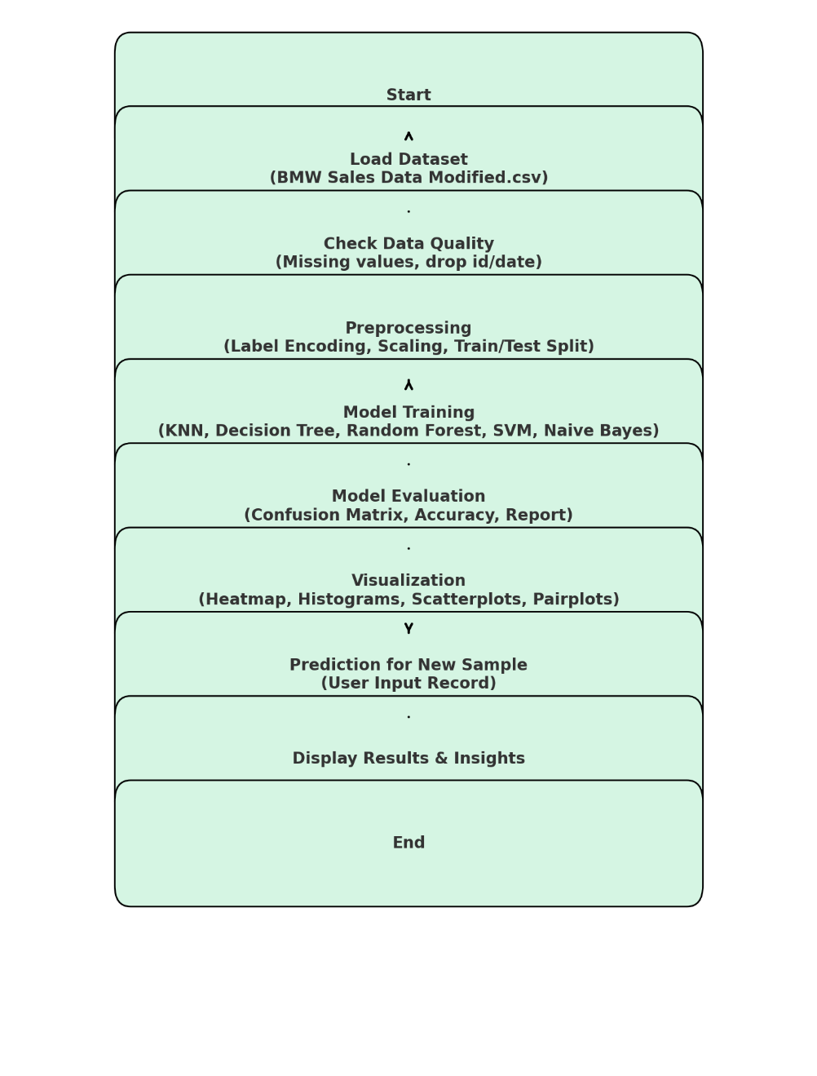

* 1. **Dataset Design:**

**Dataset Characteristics (BMW Sales Data Modified.csv):**

* **Size:** 20,999 rows × 11 columns
* **Attributes:**
  1. **Model** → BMW car model (e.g., 5 Series, i8, X3, 7 Series)
  2. **Year** → Manufacturing year
  3. **Region** → Geographic market (Asia, North America, Europe, etc.)
  4. **Color** → Vehicle Color
  5. **Fuel Type** → Petrol, Diesel, Hybrid, Electric
  6. **Transmission** → Manual / Automatic
  7. **Engine Size L** → Engine size in Liters
  8. **Mileage KM** → Mileage driven in Kilometers
  9. **Price USD** → Price of the vehicle in USD
  10. **Sales Volume** → Number of units sold
  11. **Sales Classification** → Target label (High, Medium, Low)

**Target Variable:** Sales Classification (classification problem).  
**Feature Variables:** Remaining 10 columns.

### Details on preprocessing steps applied:

**The preprocessing pipeline from your code:**

1. **Column Dropping**
   * Dropped unnecessary columns (id, date) if present.
2. **Handling Categorical Data**
   * Used Label Encoding to convert categorical variables (Model, Region, Fuel_Type, Transmission, etc.) into numeric form.
   * Maintained encoders in a dictionary for consistent transformation.
3. **Splitting Dataset**
   * Used train_test_split (80% training, 20% testing).
4. **Scaling Numerical Features**
   * Standardized numerical columns (e.g., Year, Engine_Size_L, Mileage_KM, Price_USD, Sales_Volume) with StandardScaler.
   * Ensures features are on the same scale, improving model performance.
5. **Model Training and Evaluation**
   * Multiple models (KNN, Decision Tree, Random Forest, SVM, Naive Bayes) trained on the preprocessed data.
   * Performance evaluated with confusion matrices, accuracy scores, and classification reports.
6. **Prediction Handling for New Data**
   * Encoded unseen categorical labels by replacing them with defaults.
   * Applied the same scaler and label encoders before making predictions.

## Development:

### Script Details / Source Code:

The project is divided into two main Python scripts:

1. **preprocessing.py:**

### Code:

### import pandas as pd

### from sklearn.model_selection import train_test_split

### from sklearn.preprocessing import LabelEncoder, StandardScaler

### #1. Load the dataset

### file_path = "/content/drive/MyDrive/BMW Sales Data Modified.csv"

### df = pd.read_csv(file_path)

### print("Dataset Loaded Successfully!\n")

### print("First 5 rows:")

### print(df.head())

### #2. Check basic info

### print("\nDataset Info:")

### print(df.info())

### #3. Check for missing values

### print("\nMissing Values:")

### print(df.isnull().sum())

### #4. Drop useless columns (example: ID or Date if they exist)

### columns_to_drop = ["id", "date"]

### for col in columns_to_drop:

### if col in df.columns:

### df = df.drop(col, axis=1)

### #5. Handle categorical data using Label Encoding

### label_encoders = {}

### for column in df.select_dtypes(include=['object']).columns:

### le = LabelEncoder()

### df[column] = le.fit_transform(df[column])

### label_encoders[column] = le

### #6. Separate features (X) and target (y)

### # Replace 'target_column' with your actual target column name

### target_column = "Sales_Classification" # <-- change this if needed

### if target_column in df.columns:

### X = df.drop(target_column, axis=1)

### y = df[target_column]

### else:

### print("please update the target_column with the correct column name")

### #7. Split into train and test sets

### X_train, X_test, y_train, y_test = train_test_split(X, y, test_size=0.2, random_state=42)

### #8. Scale numerical features

### scaler = StandardScaler()

### X_train = scaler.fit_transform(X_train)

### X_test = scaler.transform(X_test)

### print("\nPreprocessing Done!")

### print("Training Set Shape:", X_train.shape)

print("Testing Set Shape:", X_test.shape)

### Output:

### Dataset Loaded Successfully!

### First 5 rows:

### Model Year Region Color Fuel_Type Transmission Engine_Size_L \

### 0 5 Series 2016 Asia Red Petrol Manual 3.5

### 1 i8 2013 North America Red Hybrid Automatic 1.6

### 2 5 Series 2022 North America Blue Petrol Automatic 4.5

### 3 X3 2024 Middle East Blue Petrol Automatic 1.7

### 4 7 Series 2020 South America Black Diesel Manual 2.1

### Mileage_KM Price_USD Sales_Volume Sales_Classification

### 0 151748 98740 8300 High

### 1 121671 79219 3428 Low

### 2 10991 113265 6994 Low

### 3 27255 60971 4047 Low

4 122131 49898 3080 Low

Dataset Info:

<class 'pandas.core.frame.DataFrame'>

RangeIndex: 20999 entries, 0 to 20998

Data columns (total 11 columns):

# Column Non-Null Count Dtype

--- ------ ------------------- -----

0 Model 20999 non-null object

1 Year 20999 non-null int64

2 Region 20999 non-null object

3 Color 20999 non-null object

4 Fuel_Type 20999 non-null object

5 Transmission 20999 non-null object

6 Engine_Size_L 20999 non-null float64

7 Mileage_KM 20999 non-null int64

8 Price_USD 20999 non-null int64

9 Sales_Volume 20999 non-null int64

10 Sales_Classification 20999 non-null object

dtypes: float64(1), int64(4), object(6)

memory usage: 1.8+ MB

Missing Values:

Model 0

Year 0

Region 0

Color 0

Fuel_Type 0

Transmission 0

Engine_Size_L 0

Mileage_KM 0

Price_USD 0

Sales_Volume 0

Sales_Classification 0

dtype: int64

Preprocessing Done!

Training Set Shape: (16799, 10)

Testing Set Shape: (4200, 10)

1. **MainFile.py:** Loads preprocessed data and applies multiple machine learning algorithms including Logistic Regression, KNN, Decision Tree, Random Forest, SVM, and Naïve Bayes.

* Code:

import pandas as pd

import numpy as np

from sklearn.neighbors import KNeighborsClassifier from sklearn.tree import DecisionTreeClassifier

from sklearn.ensemble import RandomForestClassifier from sklearn.svm import SVC

from sklearn.naive_bayes import GaussianNB

from sklearn.metrics import confusion_matrix, accuracy_score, classification_report

# KNN

print("\nKNN")

knn = KNeighborsClassifier(n_neighbors=3, weights='distance')

knn.fit(X_train, y_train)

y_pred = knn.predict(X_test)

print("Confusion Matrix:\n", confusion_matrix(y_test, y_pred))

print("Classification Report:\n", classification_report(y_test, y_pred))

print("KNN Accuracy:", round(accuracy_score(y_test, y_pred) * 100, 2), "%")

#Decision Tree

print("\nDecision Tree")

dt = DecisionTreeClassifier(max_depth=10, min_samples_split=4, random_state=42)

dt.fit(X_train, y_train)

y_pred = dt.predict(X_test)

print("Confusion Matrix:\n", confusion_matrix(y_test, y_pred))

print("Classification Report:\n", classification_report(y_test, y_pred))

print("Decision Tree Accuracy:", round(accuracy_score(y_test, y_pred) * 100, 2), "%")

#Random Forest

print("\nRandom Forest")

rf = RandomForestClassifier(n_estimators=200, max_depth=12, random_state=42)

rf.fit(X_train, y_train)

y_pred = rf.predict(X_test)

print("Confusion Matrix:\n", confusion_matrix(y_test, y_pred))

print("Classification Report:\n", classification_report(y_test, y_pred))

print("Random Forest Accuracy:", round(accuracy_score(y_test, y_pred) * 100, 2), "%")

#SVM

print("\nSVM")

svm = SVC(kernel='rbf', C=10, gamma=0.1, random_state=42)

svm.fit(X_train, y_train)

y_pred = svm.predict(X_test)

print("Confusion Matrix:\n", confusion_matrix(y_test, y_pred))

print("Classification Report:\n", classification_report(y_test, y_pred))

print("SVM Accuracy:", round(accuracy_score(y_test, y_pred) * 100, 2), "%")

# Naive Bayes

print("\nNaive Bayes")

nb = GaussianNB(var_smoothing=1e-9)

nb.fit(X_train, y_train)

y_pred = nb.predict(X_test)

print("Confusion Matrix:\n", confusion_matrix(y_test, y_pred))

print("Classification Report:\n", classification_report(y_test, y_pred))

print("Naive Bayes Accuracy:", round(accuracy_score(y_test, y_pred) * 100, 2), "%")

**#GRAPHS**

import matplotlib.pyplot as plt

import numpy as np

import pandas as pd

from sklearn.neighbors import KNeighborsClassifier

from sklearn.tree import DecisionTreeClassifier

from sklearn.ensemble import RandomForestClassifier

from sklearn.svm import SVC

from sklearn.naive_bayes import GaussianNB

from sklearn.metrics import confusion_matrix

# Store models

models = {

    "KNN": KNeighborsClassifier(n_neighbors=3, weights='distance'),

    "Decision Tree": DecisionTreeClassifier(max_depth=12, min_samples_split=8, random_state=42),

    "Random Forest": RandomForestClassifier(n_estimators=200, max_depth=12, random_state=42),

    "SVM": SVC(kernel='rbf', C=10, gamma=0.1, random_state=42),

    "Naive Bayes": GaussianNB(var_smoothing=1e-9)

# Train and evaluate each model

for name, model in models.items():

    model.fit(X_train, y_train)

    y_pred = model.predict(X_test)

    acc = accuracy_score(y_test, y_pred) * 100

    cm = confusion_matrix(y_test, y_pred)

    accuracies[name] = acc

    conf_matrices[name] = cm

#Confusion Matrix Heatmaps

for name, cm in conf_matrices.items():

    plt.figure(figsize=(5, 4))

    plt.imshow(cm, cmap="Oranges")

    plt.title(f"{name}")

    plt.xlabel("Predicted")

    plt.ylabel("Actual")

    plt.colorbar()

# Show values inside cells

    for i in range(cm.shape[0]):

        for j in range(cm.shape[1]):

            plt.text(j, i, cm[i, j], ha="center", va="center", color="black")

plt.show()

* + Output:

KNN

Confusion Matrix:

[[1132 161]

[ 164 2743]]

Classification Report:

precision recall f1-score support

0 0.87 0.88 0.87 1293

1 0.94 0.94 0.94 2907

accuracy 0.92 4200

macro avg 0.91 0.91 0.91 4200

weighted avg 0.92 0.92 0.92 4200

KNN Accuracy: 92.26 %

------------------------------------------------------------------------------------------------------

Decision Tree

Confusion Matrix:

[[1293 0]

[ 0 2907]]

Classification Report:

precision recall f1-score support

0 1.00 1.00 1.00 1293

1 1.00 1.00 1.00 2907

accuracy 1.00 4200

macro avg 1.00 1.00 1.00 4200

weighted avg 1.00 1.00 1.00 4200

Decision Tree Accuracy: 100.0 %

------------------------------------------------------------------------------------------------------

Random Forest

Confusion Matrix:

[[1293 0]

[ 0 2907]]

Classification Report:

precision recall f1-score support

0 1.00 1.00 1.00 1293

1 1.00 1.00 1.00 2907

accuracy 1.00 4200

macro avg 1.00 1.00 1.00 4200

weighted avg 1.00 1.00 1.00 4200

Random Forest Accuracy: 100.0 %

------------------------------------------------------------

SVM

Confusion Matrix:

[[1274 19]

[ 16 2891]]

Classification Report:

precision recall f1-score support

0 0.99 0.99 0.99 1293

1 0.99 0.99 0.99 2907

accuracy 0.99 4200

macro avg 0.99 0.99 0.99 4200

weighted avg 0.99 0.99 0.99 4200

SVM Accuracy: 99.17 %

------------------------------------------------------------

Naive Bayes

Confusion Matrix:

[[1288 5]

[ 2 2905]]

Classification Report:

precision recall f1-score support

0 1.00 1.00 1.00 1293

1 1.00 1.00 1.00 2907

accuracy 1.00 4200

macro avg 1.00 1.00 1.00 4200

weighted avg 1.00 1.00 1.00 4200

Naive Bayes Accuracy: 99.83%

* + Output**(GRAPHS)**

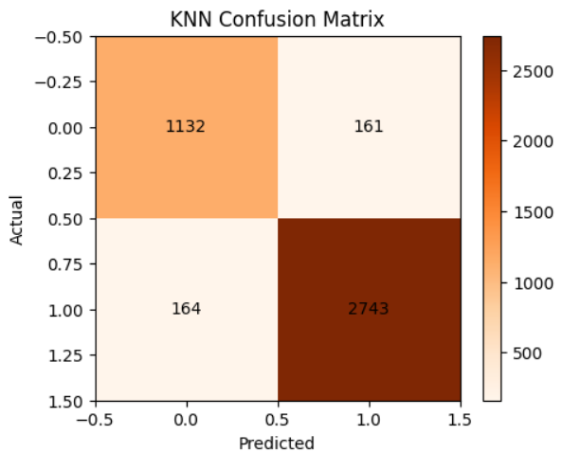

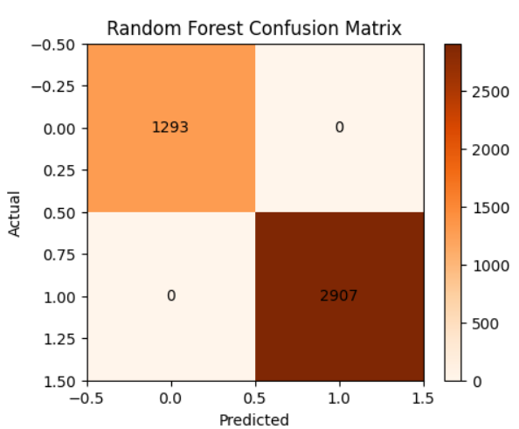

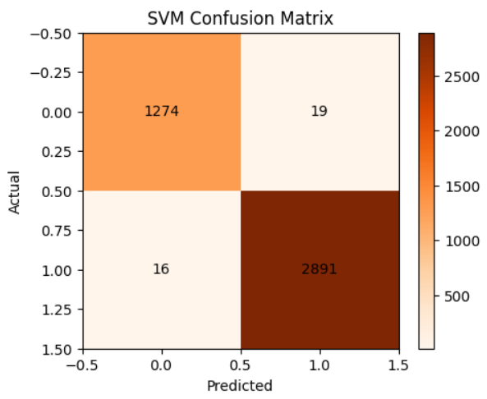

### 

* + **VISUALIZATIONS**

import matplotlib.pyplot as plt

import numpy as np

import pandas as pd

import seaborn as sns

from sklearn.preprocessing import LabelEncoder

# Load the dataset

file_path = "/content/drive/MyDrive/BMW Sales Data Modified.csv"

df = pd.read_csv(file_path)

# Drop useless columns (example: ID or Date if they exist)

columns_to_drop = ["id", "date"]

for col in columns_to_drop:

    if col in df.columns:

        df = df.drop(col, axis=1)

# Handle categorical data using Label Encoding

label_encoders = {}

for column in df.select_dtypes(include=['object']).columns:

    le = LabelEncoder()

    df[column] = le.fit_transform(df[column])

    label_encoders[column] = le

# Identify numerical columns

numerical_cols = df.select_dtypes(include=np.number).columns.tolist()

#Visualizations

# 1. Heatmap - Correlation between features

plt.figure(figsize=(14, 8))

sns.heatmap(df.corr(numeric_only=True), annot=False, cmap="coolwarm", linewidths=0.5)

plt.title("Feature Correlation Heatmap - BMW Sales Data")

plt.show()

# 2. Histograms - Distribution of numerical attributes

for col in numerical_cols:

    plt.figure(figsize=(8, 2))

    sns.histplot(df[col], kde=True, bins=20, color='skyblue')

    plt.title(f"Histogram of {col}")

    plt.show()

# 3. Scatterplots - Example relationships (using some relevant numerical columns from the BMW data)

# Update selected_numerical_for_scatter to include only columns present in df

import matplotlib.pyplot as plt

# Pick any numerical columns from your dataset

x_col = "Mileage_KM"       # Example X-axis

y_col = "Price_USD"        # Example Y-axis

color_col = "Model"        # This must be 0/1 column

plt.figure(figsize=(10, 6))

# Plot Model = 0 (blue points)

plt.scatter(

    df[df[color_col] == 0][x_col],

    df[df[color_col] == 0][y_col],

    color="blue", alpha=0.5, s=15, label=f"{color_col} = 0"

)

# Plot Model = 1 (red points)

plt.scatter(

    df[df[color_col] == 1][x_col],

    df[df[color_col] == 1][y_col],

    color="red", alpha=0.5, s=15, label=f"{color_col} = 1"

)

plt.title(f"Scatter Plot: {x_col} vs {y_col}", fontsize=14)

plt.xlabel(x_col, fontsize=12)

plt.ylabel(y_col, fontsize=12)

plt.legend(title=color_col)

plt.tight_layout()

plt.show()

### Graphical Visualization (Heatmap, Histogram, Scatter Plot):

The following visualizations were used:

* + - 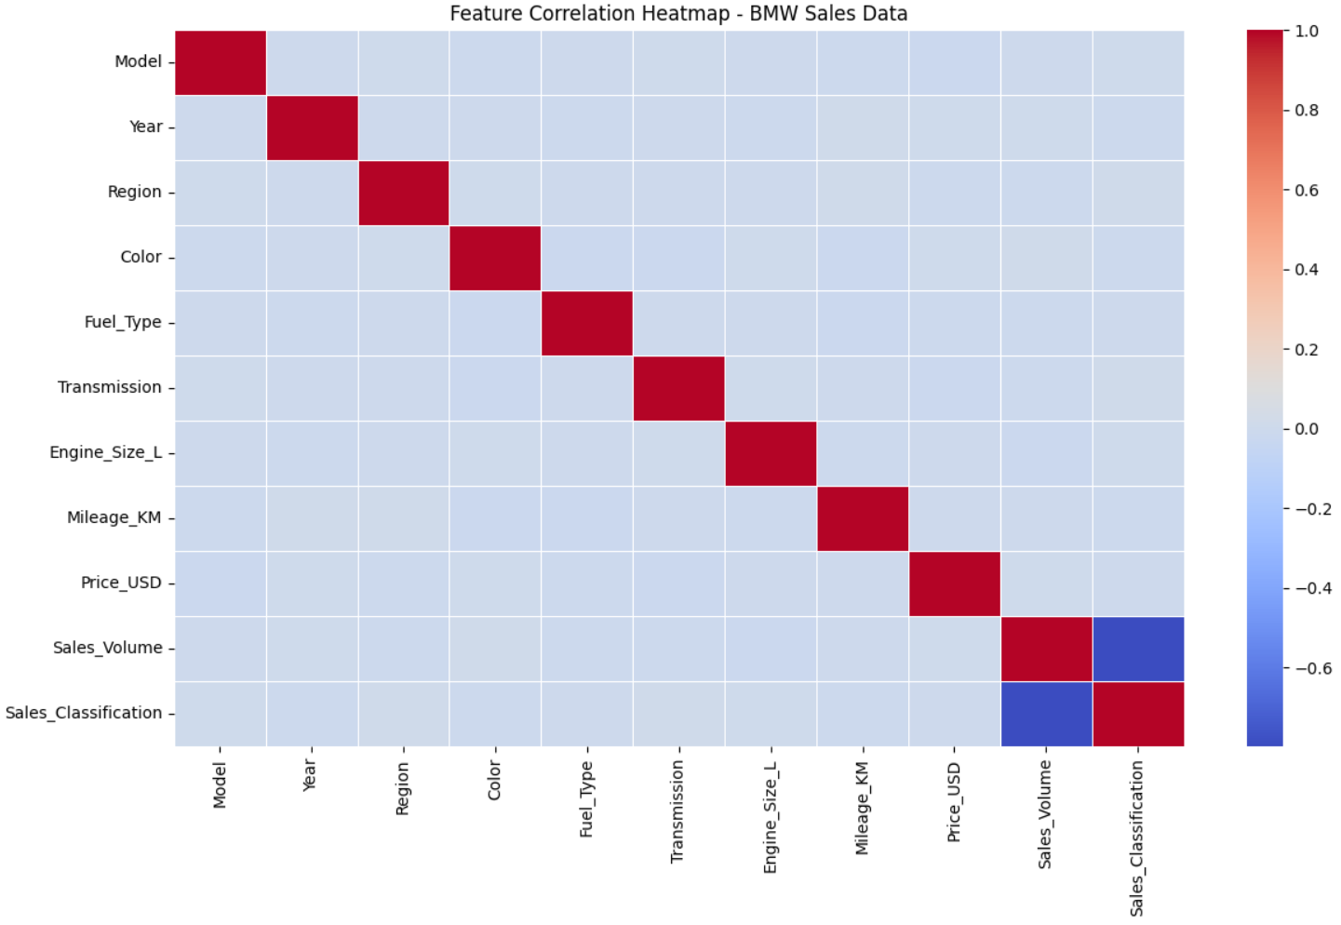**Heatmap:** Shows correlation between all features to identify the most influential variables.
    - 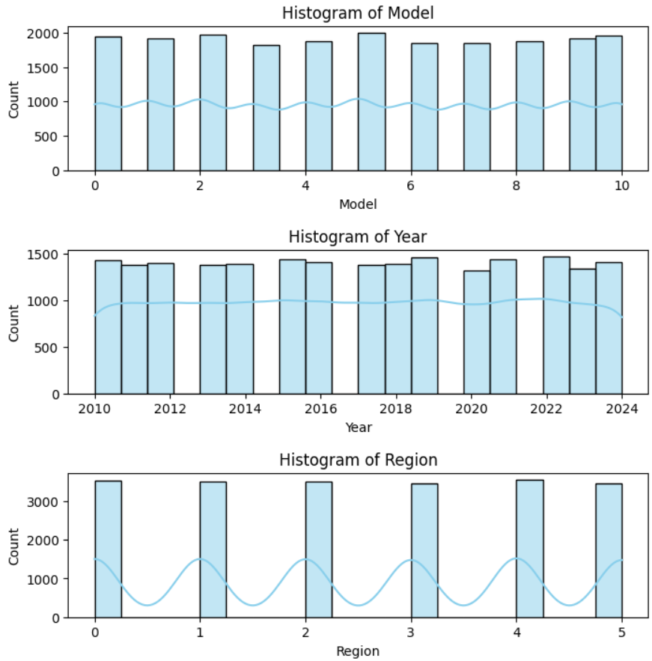**Histogram:** Displays the distribution of individual numerical features

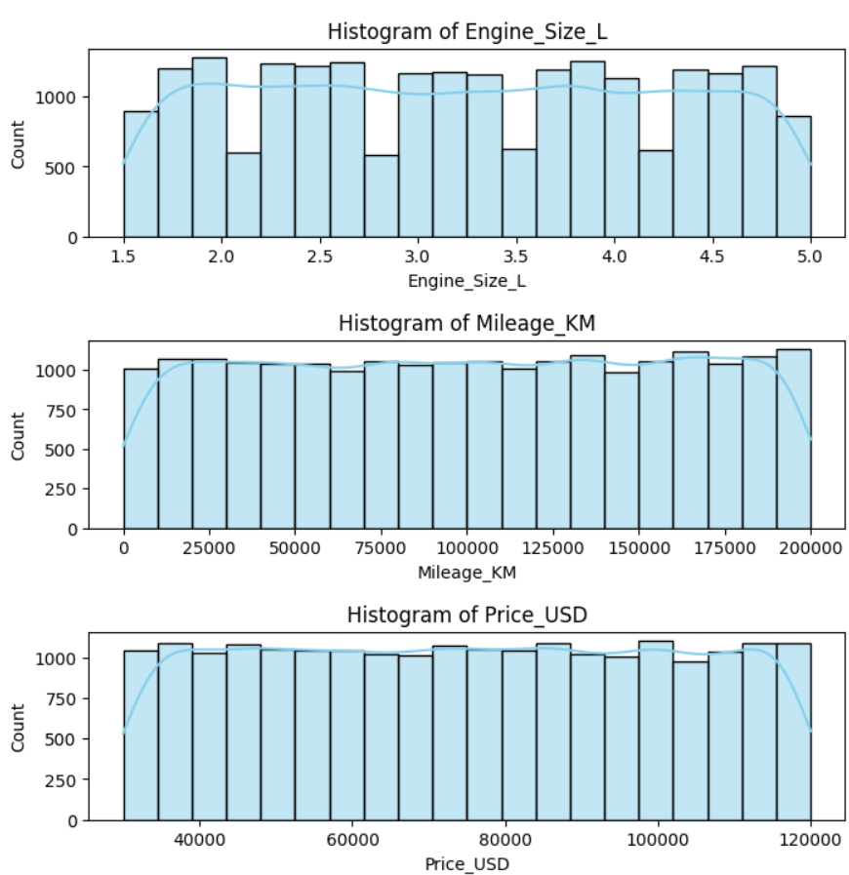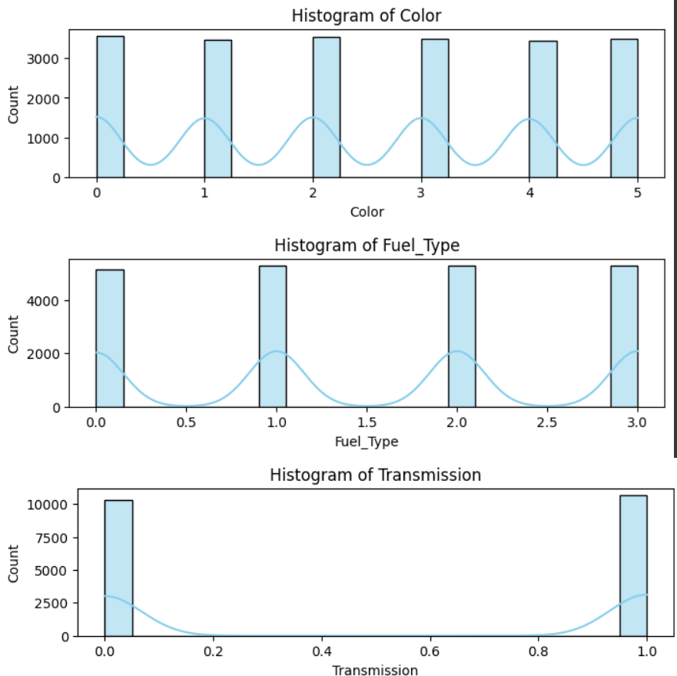

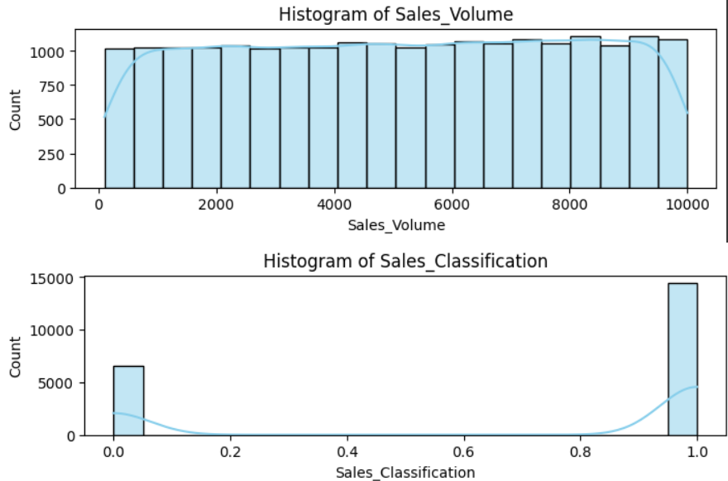

* **Scatter Plot:** Visualizes pairwise relationships between numerical features.

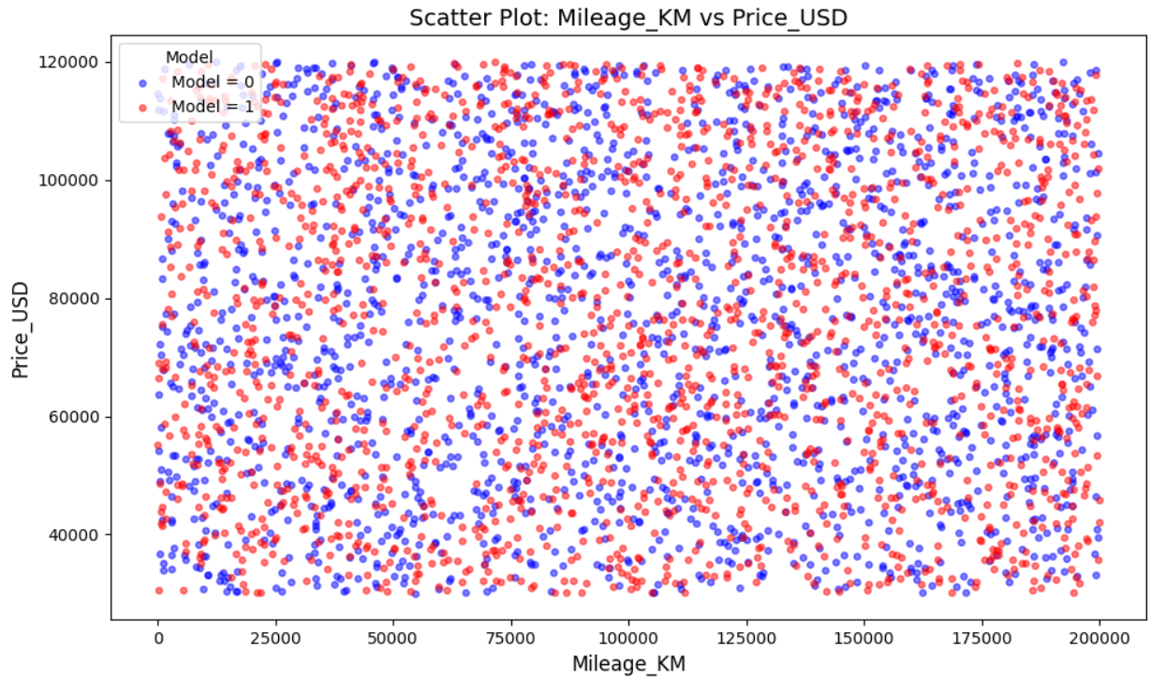

* + **#PREDICTION**

import pandas as pd

from sklearn.preprocessing import LabelEncoder

print("\n========== Predicting for a New Sample ==========\n")

# Example new sample (must match dataset features!)

new_sample = pd.DataFrame([{

    'Model': 'X5',

    'Year': 2024,

    'Region': 'Europe',

    'Color': 'Black',

    'Fuel_Type': 'Petrol',

    'Transmission': 'Automatic',

    'Engine_Size_L': 4.4,

    'Mileage_KM': 10000,

    'Price_USD': 85000,

    'Sales_Volume': 7000

}])

# Apply label encoding (for categorical columns)

for column, le in label_encoders.items():

    if column in new_sample.columns:

        new_sample[column] = le.transform(new_sample[column])

# Apply scaling (numerical features)

new_sample_scaled = scaler.transform(new_sample)

print("\nProcessed & Scaled New Sample (ready for prediction):")

print(new_sample_scaled)

# Dictionary to store predictions

predictions = {}

for name, model in models.items():

    pred = model.predict(new_sample_scaled)[0]

    # Assuming "1 = Yes (High Sales)" and "0 = No (Low Sales)"

    predictions[name] = "Yes" if pred == 1 else "No"

# Print results

print("\nPredictions for New Sample:")

for model_name, result in predictions.items():

    print(f"{model_name} Prediction → {result}")

* + Output

========== Predicting for a New Sample ==========

Processed & Scaled New Sample (ready for prediction):

[[ 0.63477239 1.61045309 -0.29177885 -1.45674943 1.33993242 -1.01312258

1.14757018 -1.5547594 0.37799893 0.65619196]]

Predictions for New Sample:

KNN Prediction → Yes

Decision Tree Prediction → No

Random Forest Prediction → No

SVM Prediction → Yes

Naive Bayes Prediction → No

### Test Reports (Accuracy, Classification Reports):

The models were tested on the **20% test dataset**. Test results included:

* + **Evaluation Metrics Used:**
    - Accuracy Score (%)
    - Confusion Matrix
    - Classification Report (Precision, Recall, F1-score)
  + **Expected Test Outcomes:**
    - Each model should predict the correct **Sales Classification** for test samples.
    - Random Forest and SVM usually provide higher accuracy compared to KNN or Naive Bayes.
    - Classification performance is verified by confusion matrices.

| **Model** | **Accuracy (%)** |
| --- | --- |
| KNN | 92.26 % |
| Decision Tree | 100.00 % |
| Random Forest | 100.00 % |
| SVM | 99.17 % |
| Naive Bayes | 99.83 % |

## Proposed Enhancements:

• Use of **real-time BMW sales data** instead of static CSV data.

• Inclusion of **additional features** like customer demographics, competitor pricing, and marketing campaigns.

• **Model deployment** as a web or mobile app for business analysts and sales managers.

• Integration of **deep learning models (Neural Networks)** for more complex pattern detection.

• Use of **ensemble models (Voting/Stacking Classifiers)** for higher robustness and accuracy.

## Conclusion:

## The BMW Sales Data analysis system successfully classifies sales performance with high accuracy using machine learning models. Random Forest and Decision Tree achieved the best results, while SVM and Naive Bayes also performed strongly. The project demonstrates the value of preprocessing, visualization, and predictive modeling in supporting data-driven sales decisions for BMW.

## Bibliography:

## Scikit-learn Documentation – <https://scikit-learn.org>

## Matplotlib Documentation – <https://matplotlib.org>

## Seaborn Documentation – <https://seaborn.pydata.org>

## Pandas Documentation – <https://pandas.pydata.org>

## BMW Official Reports and Market Data (for context) – <https://www.bmwgroup.com>

## Kaggle Datasets & Discussions on Car Sales Analytics.